RDS MySQL that was created as a multi-AZ instance has the primary AZ as us-east-1b and secondary as us-east-1a initially as shown below.

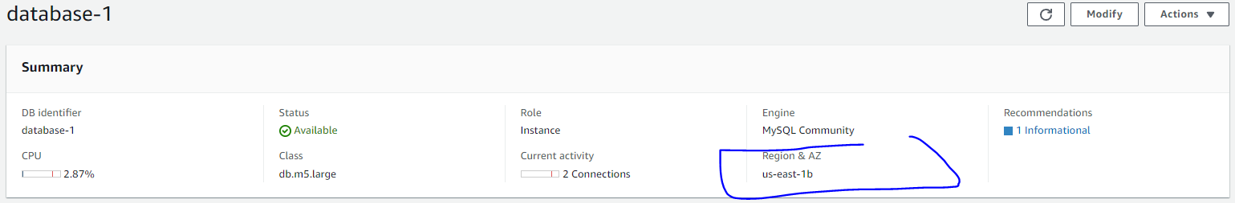

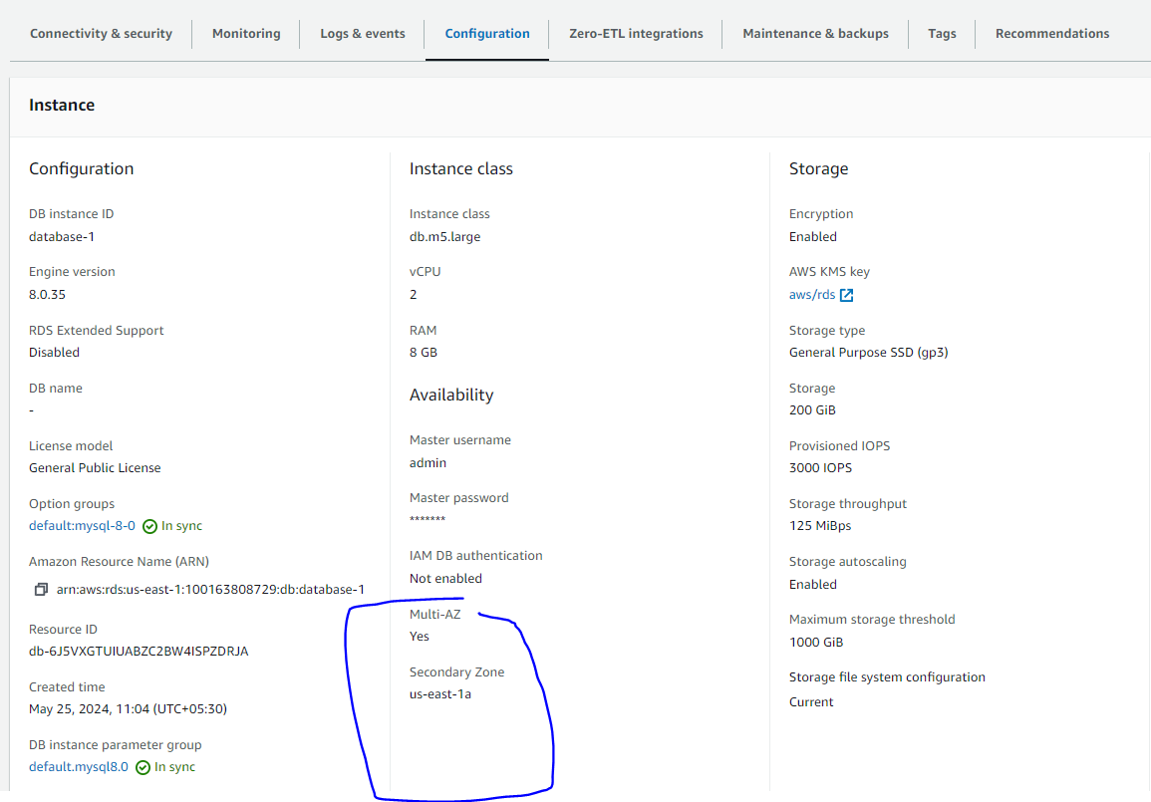

To simulate database failure, go to Actions -> Reboot -> Reboot with failover.

After failover, you will notice that primary AZ becomes us-east-1a and secondary is us-east-1b. Also, without any change in the application or the MySQL client (like workbench), records will get inserted into the database and can be queried as well.

